ELEVATION SYSTEM
******
Installation Guide

- Open SQL Server 2008, enter login name and password to login system of SQL Server 2008

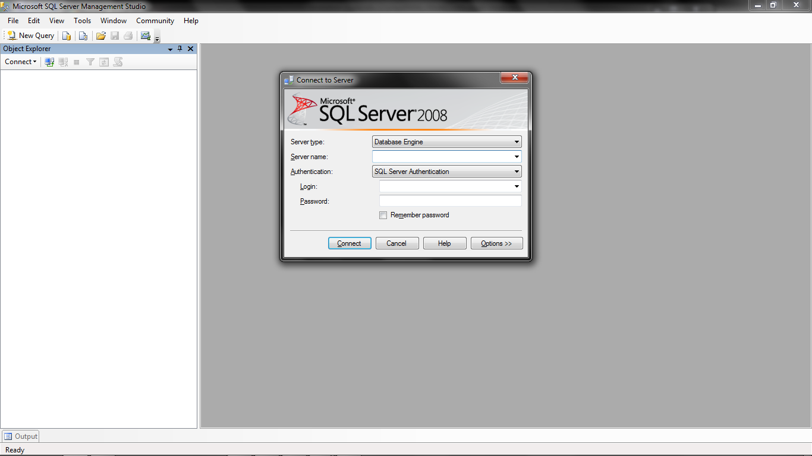
Figure 1: SQL Server 2008 Login

- Right click on “Database” and choose “New Database…”

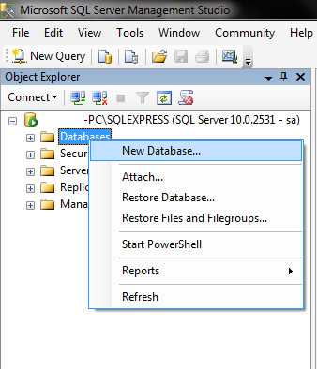
Figure 2: Select New database
- Database name will be “ElevationSystem”, then click OK

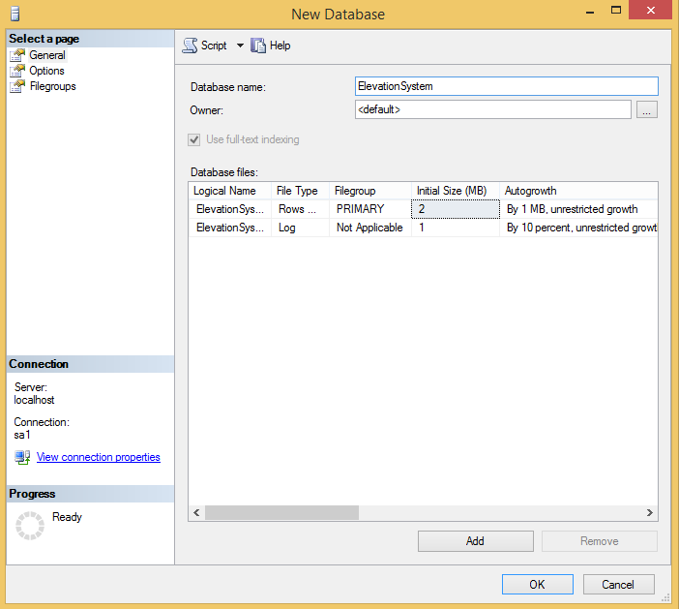
Figure 3: Create new Database

- Then open file “ElevationSystem.sql”

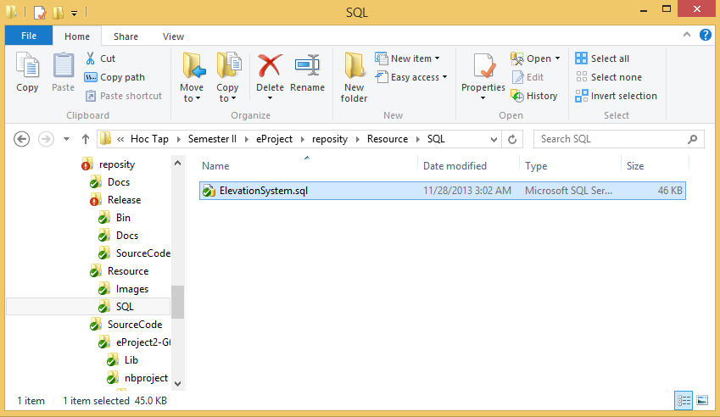
Figure 4: Open SQL file

- Then Press F5 button
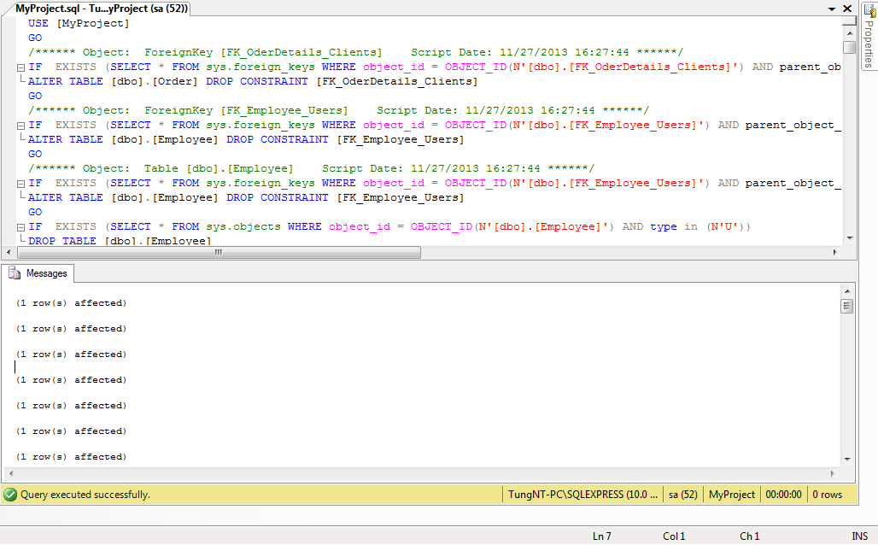
Figure 5: Press F5 button to query
- After that open “Elevation System” then enter your username and password

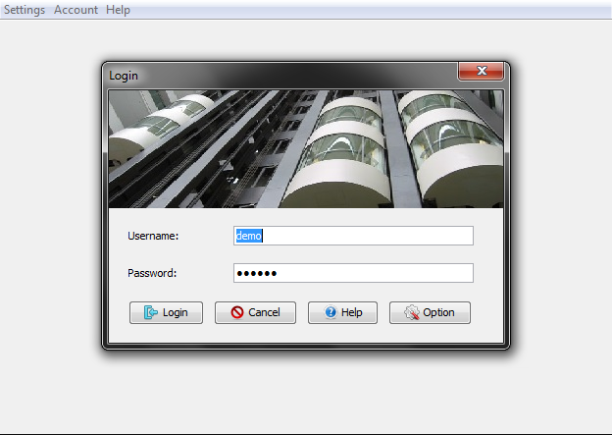
Figure 6: Login screen

- The details will be (Server name: localhost; Port: 1433; Database: ElevatorSystem; Username: sa; Password: 123456;). Then click “Test and connect”
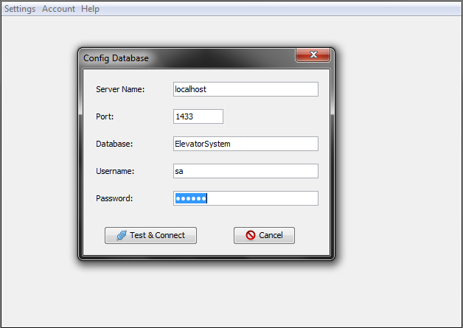
Figure 7: Config Database

- After that, input your user name and password to login

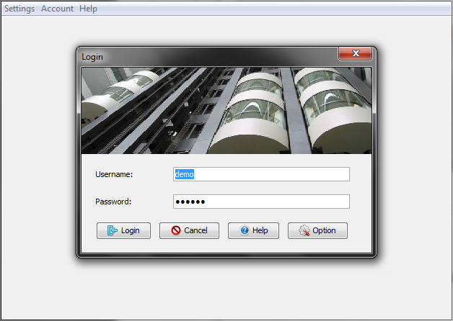
Figure 8: Login screen

For more help and information about product please contact:
Group: 6
Email: - toanlmgc00250@fpt.edu.vn
- phuonglhgc00112@fpt.edu.vn
- tungntgc00186@fpt.edu.vn
Thanks you!

